Geometric Pole Pair

Definition
# Source: AI Source: Provided by: [Data Path: Persons Table -> ID Column: 1, Name_En Column: Motasem Essam] -> From: [ChatGPT] on [7/25/2026]
A geometric pole pair is a pair of diametrically opposite points on the surface of a sphere, defined by a selected diameter or axis. The two points lie on the same straight line through the sphere’s center and are each one radius away from it.
Unlike the geographic North Pole and South Pole, a geometric pole pair does not inherently have a north–south orientation. The two poles can be labeled $P$ and $P'$, $N$ and $S$, or by any other convenient notation.
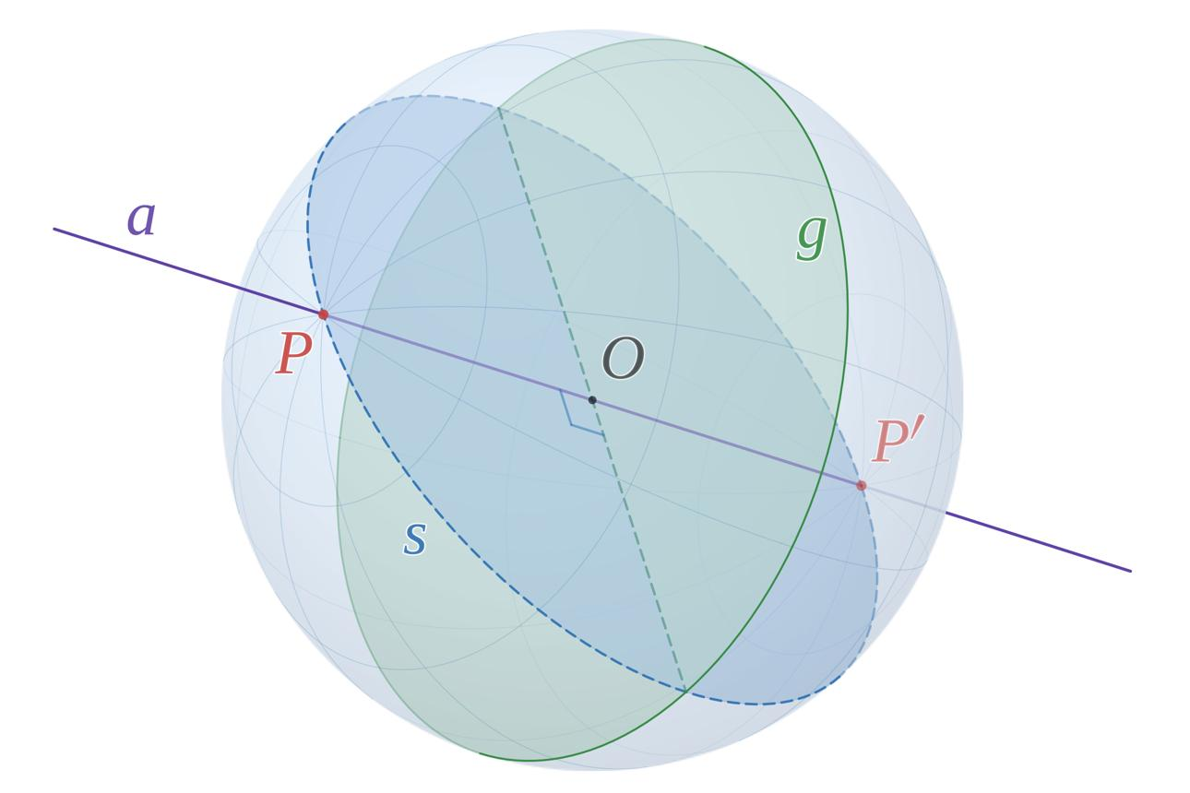
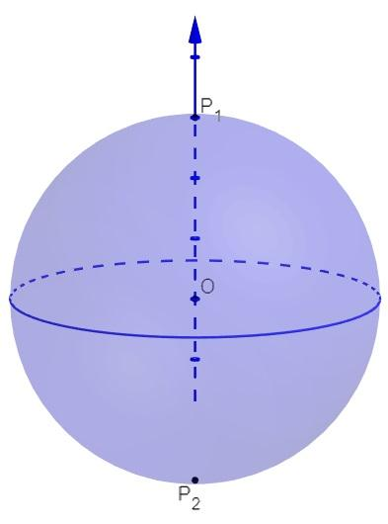
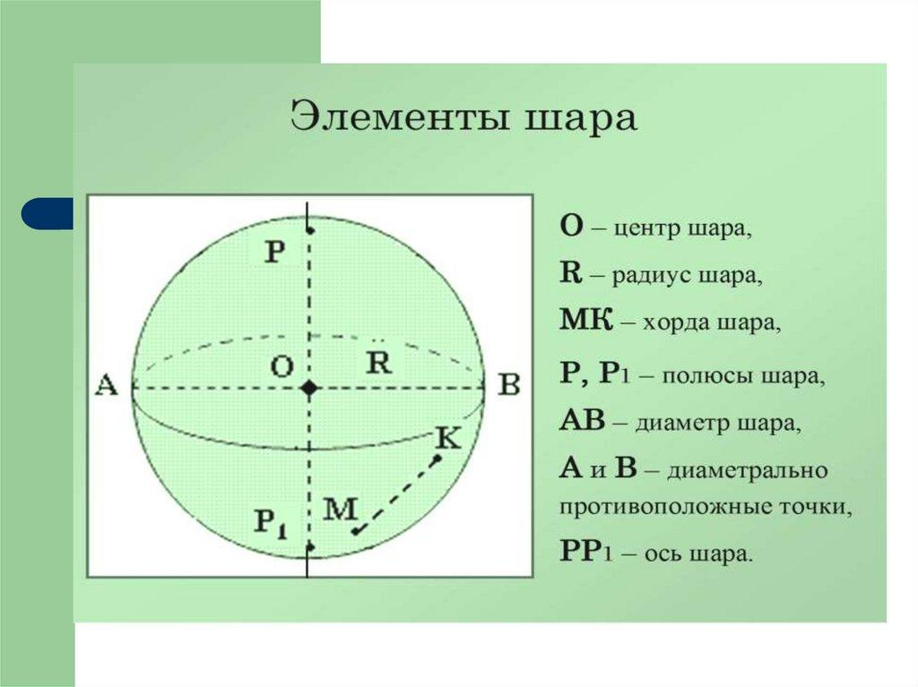

Simple Definition
# Source: AI Source: Provided by: [Data Path: Persons Table -> ID Column: 1, Name_En Column: Motasem Essam] -> From: [ChatGPT] on [7/25/2026]
A geometric pole pair consists of two opposite points on a sphere’s surface connected by a diameter.
- First pole: One endpoint of the selected diameter.
- Second pole: The opposite endpoint.
- Sphere center: The midpoint between the two poles.
- Polar axis: The diameter connecting the poles through the center.

Geometric Representation
# Source: AI Source: Provided by: [Data Path: Persons Table -> ID Column: 1, Name_En Column: Motasem Essam] -> From: [ChatGPT] on [7/25/2026]
Consider a sphere with center $O$, radius $R$, and two poles $P$ and $Q$.
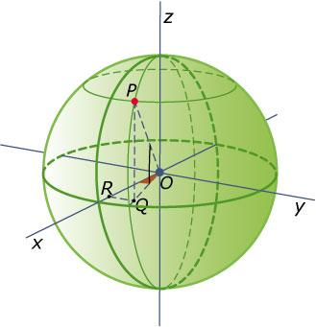
The points lie on a straight line:
$$P - O - Q$$
The fundamental relationships are:
$$OP=OQ=R$$
$$PQ=2R$$
The center $O$ is the midpoint of diameter $PQ$.

Key Characteristics
# Source: AI Source: Provided by: [Data Path: Persons Table -> ID Column: 1, Name_En Column: Motasem Essam] -> From: [ChatGPT] on [7/25/2026]
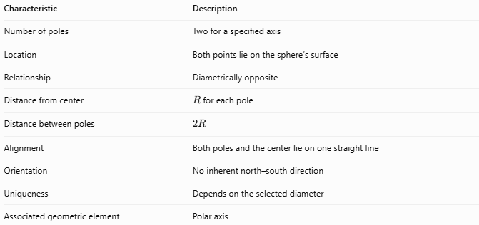
Characteristic | Description
Number of poles | Two for a specified axis
Location | Both points lie on the sphere’s surface
Relationship | Diametrically opposite
Distance from center | $R$ for each pole
Distance between poles | $$2R$$
Alignment | Both poles and the center lie on one straight line
Orientation | No inherent north–south direction
Uniqueness | Depends on the selected diameter
Associated geometric element | Polar axis

Mathematical Properties
# Source: AI Source: Provided by: [Data Path: Persons Table -> ID Column: 1, Name_En Column: Motasem Essam] -> From: [ChatGPT] on [7/25/2026]
Let the sphere have center $O$ and radius $R$.

Distance from the center
# Source: AI Source: Provided by: [Data Path: Persons Table -> ID Column: 1, Name_En Column: Motasem Essam] -> From: [ChatGPT] on [7/25/2026]
Each pole is exactly one radius from the center:
$$OP=OQ=R$$

Distance between the poles
# Source: AI Source: Provided by: [Data Path: Persons Table -> ID Column: 1, Name_En Column: Motasem Essam] -> From: [ChatGPT] on [7/25/2026]
Because the poles are endpoints of a diameter:
$$PQ=OP+OQ=2R$$

Coordinate representation
# Source: AI Source: Provided by: [Data Path: Persons Table -> ID Column: 1, Name_En Column: Motasem Essam] -> From: [ChatGPT] on [7/25/2026]
For a sphere centered at the origin, choose the $z$-axis as the polar axis. The pole coordinates are:
$$P=\left(0,0,R\right)$$
$$Q=\left(0,0,-R\right)$$
These are opposite points because their position vectors have equal magnitudes and opposite directions.
More generally, for a sphere centered at the origin, a unit direction vector $u$ defines a pole pair:
$$P=Ru, Q=-Ru$$
This representation works for any chosen direction through the center.

Types of Sphere Poles
# Source: AI Source: Provided by: [Data Path: Persons Table -> ID Column: 1, Name_En Column: Motasem Essam] -> From: [ChatGPT] on [7/25/2026]
Sphere poles can be classified according to the meaning or purpose of the selected pole pair.
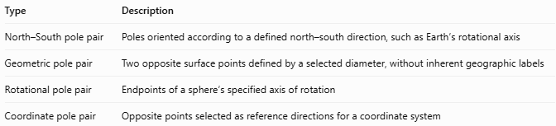
Type | Description
North–South pole pair | Poles oriented according to a defined north–south direction, such as Earth’s rotational axis
Geometric pole pair | Two opposite surface points defined by a selected diameter, without inherent geographic labels
Rotational pole pair | Endpoints of a sphere’s specified axis of rotation
Coordinate pole pair | Opposite points selected as reference directions for a coordinate system
These classifications may overlap. For example, Earth’s North and South Poles form both a rotational pole pair and a geographic pole pair.

Relationship to Other Spherical Elements
# Source: AI Source: Provided by: [Data Path: Persons Table -> ID Column: 1, Name_En Column: Motasem Essam] -> From: [ChatGPT] on [7/25/2026]
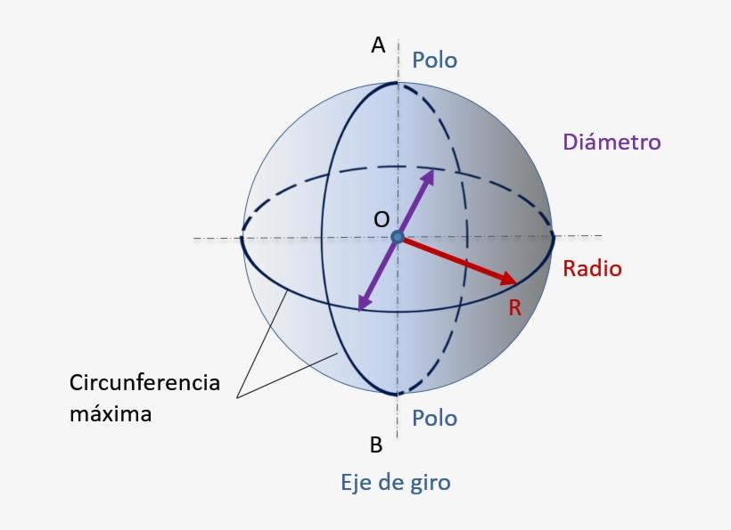
- Sphere center: The midpoint between the poles.
- Diameter: The line segment connecting the two poles through the center.
- Polar axis: The diameter selected as the reference axis.
- Equatorial plane: A plane through the center perpendicular to the polar axis.
- Equator: The great circle formed by the intersection of the equatorial plane with the sphere.
- Great circles through the poles: Every plane containing the polar axis intersects the sphere in a great circle passing through both poles.

Worked Example
# Source: AI Source: Provided by: [Data Path: Persons Table -> ID Column: 1, Name_En Column: Motasem Essam] -> From: [ChatGPT] on [7/25/2026]
A sphere has a radius of $5\text{ cm}$. Two opposite surface points $P$ and $Q$ are selected as a geometric pole pair.
Find the distance between the poles.
Since the points are endpoints of a diameter:
$$PQ=2R=2\left(5\right)$$
$$\boxed{PQ=10\text{ cm}}$$
The distance from the center to either pole is:
$$OP=OQ=5\text{ cm}$$

Geometric Pole Pair vs. Related Concepts
# Source: AI Source: Provided by: [Data Path: Persons Table -> ID Column: 1, Name_En Column: Motasem Essam] -> From: [ChatGPT] on [7/25/2026]
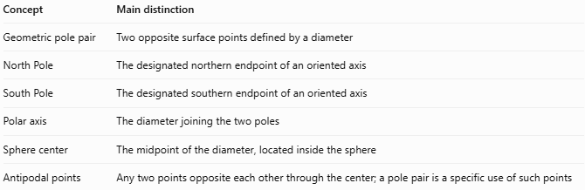
Concept | Main distinction
Geometric pole pair | Two opposite surface points defined by a diameter
North Pole | The designated northern endpoint of an oriented axis
South Pole | The designated southern endpoint of an oriented axis
Polar axis | The diameter joining the two poles
Sphere center | The midpoint of the diameter, located inside the sphere
Antipodal points | Any two points opposite each other through the center; a pole pair is a specific use of such points
Important distinction: Every geometric pole pair consists of antipodal points, but not every pair of antipodal points needs to be called a pole pair unless a diameter or reference axis has been selected.

Applications
# Source: AI Source: Provided by: [Data Path: Persons Table -> ID Column: 1, Name_En Column: Motasem Essam] -> From: [ChatGPT] on [7/25/2026]
- Coordinate geometry: Defining reference directions for spherical coordinates.
- Astronomy: Representing opposite endpoints of a celestial body's selected axis.
- Computer graphics: Establishing orientation and reference points on a spherical model.
- Mathematical modeling: Defining axes of symmetry or rotation.
- Geography: Describing the relationship between a rotational axis and a sphere’s surface.

Key Points
# Source: AI Source: Provided by: [Data Path: Persons Table -> ID Column: 1, Name_En Column: Motasem Essam] -> From: [ChatGPT] on [7/25/2026]
- A geometric pole pair contains two diametrically opposite points.
- Both points lie on the sphere’s surface.
- The center lies halfway between them.
- The distance from each pole to the center equals the radius.
- The distance between the poles equals the diameter.
- The labels north and south are optional unless an orientation has been defined.
- A sphere has infinitely many possible geometric pole pairs because it has infinitely many diameters.

Conclusion
# Source: AI Source: Provided by: [Data Path: Persons Table -> ID Column: 1, Name_En Column: Motasem Essam] -> From: [ChatGPT] on [7/25/2026]
A geometric pole pair is a pair of opposite points on a sphere’s surface defined by a selected diameter. It provides a simple way to establish a polar axis, describe a sphere’s orientation, and develop coordinate systems. Unlike geographic poles, a geometric pole pair has no inherent north–south direction, and its position depends on the chosen axis.

